## https://m.media-amazon.com/images/I/81lB4quclML._AC_SL1500_.jpg Product Description

## ESP32S ESP32 ESP-WROOM-32 Development Board 2.4GHz Dual-Core WiFi +Bluetooth 2 Function Microcontroller for Arduino (ESP32 30P, 3PCS)

* If you think you have received the wrong product, please contact us and give us a chance to correct it,We also have tech support, just contact us on Amazon,thank you.
* 1. The complete solution takes up the least printed circuit board area. This board is used with 2.4GHz dual-mode WiFi and wireless chips using 40nm TSMC low-power technology.
* 2. The best power and RF characteristics are safe, reliable and scalable for various applications.
* 3. Meticulous workmanship: The meticulous design, perfect in workmanship, durable and long service life.
* 4. Compact and portable: being so mini and light-weight, this product does not take much space and can be easily taken away.
* 5.in Arduino IDE，choose ESP32 DEV
* 6.ESP32 work on 2.3V-3.6V, 5V is not recommended because the module is unstable or not work under 5V operation
* 7.you need to driver the CP2102 before you can start using it
* 8. Durable material: This product is made of high-quality material, durable, long service time, firm and stable in use.
* 9. 38P and 30P board sizes and circuit layouts are different

## Product information

### Technical Details

|  |  |
| --- | --- |
| Wireless Type | ‎Bluetooth |

[Other Technical Details](javascript:void(0))

|  |  |
| --- | --- |
| Brand | ‎Teyleten Robot |
| Item model number | ‎A9 |
| Item Weight | ‎1.13 ounces |
| Product Dimensions | ‎2.03 x 1.12 x 0.48 inches |
| Item Dimensions LxWxH | ‎2.03 x 1.12 x 0.48 inches |
| Number of Processors | ‎2 |
| Manufacturer | ‎Teyleten Robot |
| ASIN | ‎B08246MCL5 |
| Country of Origin | ‎China |
| Date First Available | ‎November 28, 2019 |

## Schematics

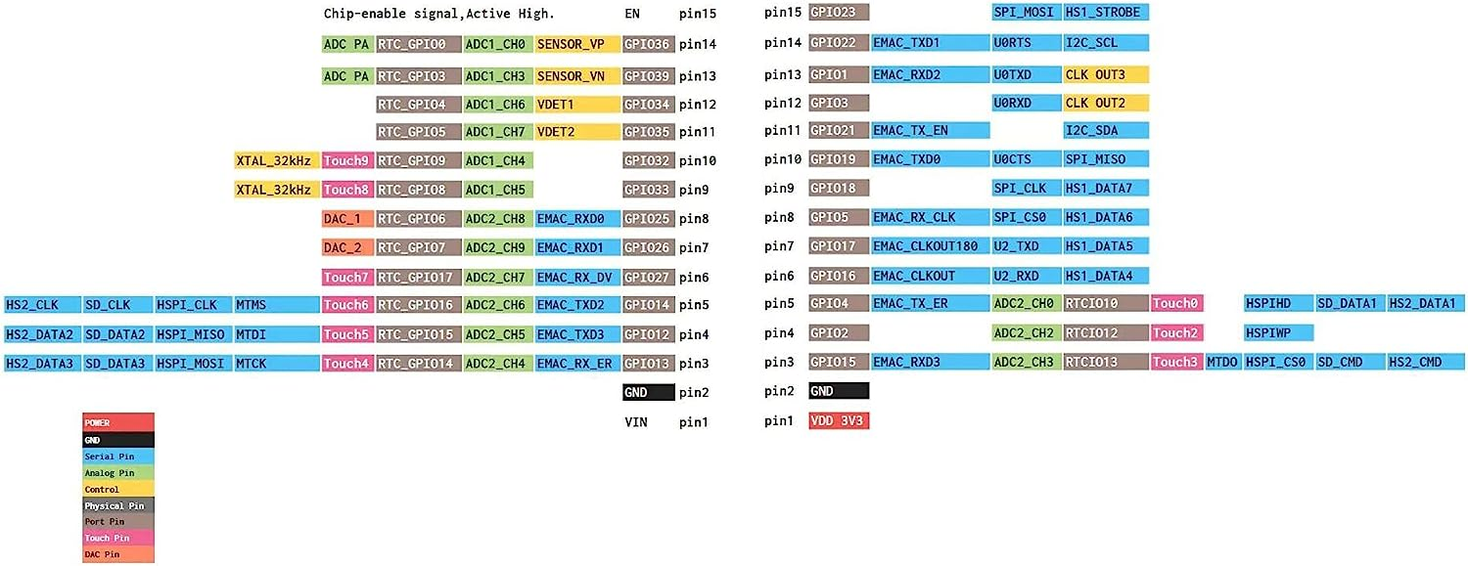

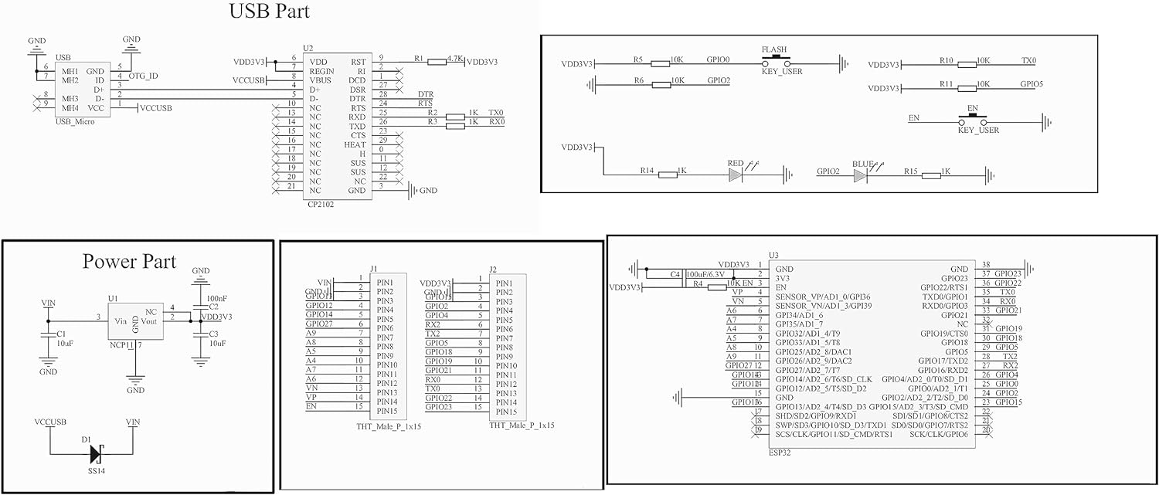

## About powering the ESP32

[ESP32 Pinout Reference - Last Minute Engineers](https://lastminuteengineers.com/esp32-pinout-reference/#:~:text=There%20are%20two%20power%20pins,an%20on%2Dboard%20voltage%20regulator.)

This site contains very useful information about the pins and how/when (not) to use them.

### Power Pins

### There are two power pins viz. VIN pin & 3.3V pin. The VIN pin can be used to directly supply the ESP32 and its peripherals, if you have a regulated 5V voltage source. The 3.3V pin is the output of an on-board voltage regulator. This pin can be used to supply power to external components. GND is a ground pin of ESP32 development board.

Other useful info with schematics on [Powering Components with ESP32 - Electrical Engineering Stack Exchange](https://electronics.stackexchange.com/questions/601348/powering-components-with-esp32)

The USB 5V seems to be connected to the VIN through a diode to prevent power on the PC USB port when external 5V power is connected to VIN. When on USB, VIN will have 4.5-5V available, e.g. for powering LEDs, LED strips or low power sensors.

### **Configure IDE**

In the Arduino IDE you must install esp32 environment, refer to “[ESP32: pinout, specs and Arduino IDE configuration](https://www.mischianti.org/2020/05/30/esp32-pinout-specs-and-arduino-ide-configuration-part-1/)“, then you must configure the correct board information, now I use an esp32-wroom-32 and I set:

